

Hello Solidity – Writing First Smart Contract



**Objective/Aim:**  
  
 Introduce the basics of Solidity and demonstrate how to write, compile, and deploy a simple smart

contract (a basic storage contract) to the Ethereum testnet using Remix and MetaMask

**Apparatus/Software Used:**

* Laptop
* Solidity (v0.8.x)
* Remix IDE
* Metamask Sepolia testnet wallet

**Theory/Concept:**

* Smart contract: a self-executing program on a blockchain which enforces rules defined in its code.
* Solidity: the language commonly used to write Ethereum smart contracts.



**Procedure:**

|  |  |  |  |
| --- | --- | --- | --- |
|  |  |  |  |
|  |  |  |  |
|  |  |  |  |
|  |  |  |  |
|  |  |  |  |
|  |  |  |  |
|  |  |  |  |

**Step 1: Open Remix IDE on your browser**

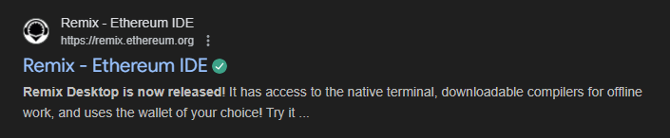

**Step 2: Create a new file give the name of the file then add “.sol” for write the code in solidity**

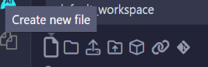

**Step 3: Then write the code for the simple storage system**

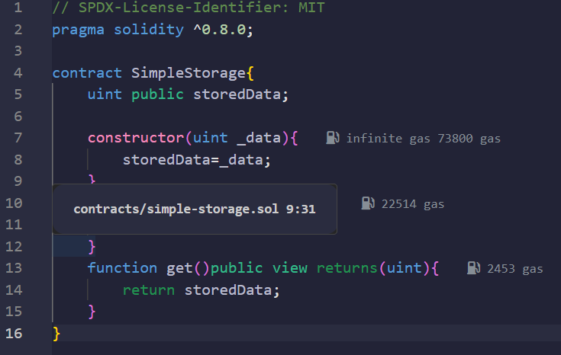

**Step 4: Go to solidity compiler and compile the code**



**Step 5: Go to the deploy and run section , set the environment as injected provider and connected the wallet enter any data and deploy the transaction**

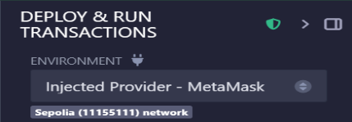

**Step 6: Confirm the transaction and the first smart contract have been deployed**

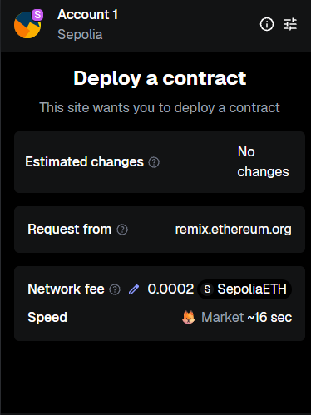

**Observation Table:**

Our first solidity smart contract deployed .

